**Design Documentation**

**For**

**<COMP 6231/2>**

Prepared by

<40040721 Luguang Liu>

<40052560 Zhongxu Huang>

<40024460 Chenwei Song>

<40025138 Jingye Hou>

# CORBA Architecture

The CORBA architecture is designed to allow clients to invoke methods in CORBA objects. Clients and objects can be implemented in a variety of programming languages.

It has the following additional components compared to RMI Object adapter, implementation repository and interface repository.

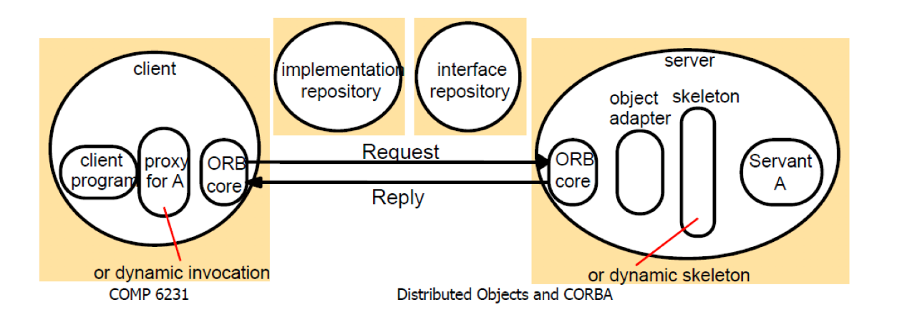

Our architecture of the assignment is like the following figure. There are parts including interface, data, server, client and logs in the system.



# IDL with CORBA

To create a complete CORBA application, we use IDL (Interface Definition Language) to define interface which includes six methods (***createStudentRecord****,* ***createTeacherRecord****,* ***getLocalCount****,* ***getServerCount****,* ***editRecord****,* ***transferRecord***). Then use Java IDL complier to generate stubs and skeletons. After the compiler process, there will be six classes generated automatically as shown below.

** **

Implementation

Compile



Then we create ***Server*** class to extend abstract class ***RecordManagerPOA*** which we write the implementation methods.

# Server Deployment in CORBA

In this assignment, we have three servers need to be bind to the CORBA object. In each server, we use function “init” to create pseudo-object. Then we use resolve_initial_reference to find POA root and activate it. We use servant_to_reference to register CORBA object. Finally, we use CORBA naming service to bind three servers to each ***NameComponent*** under the same naming context as shown below.

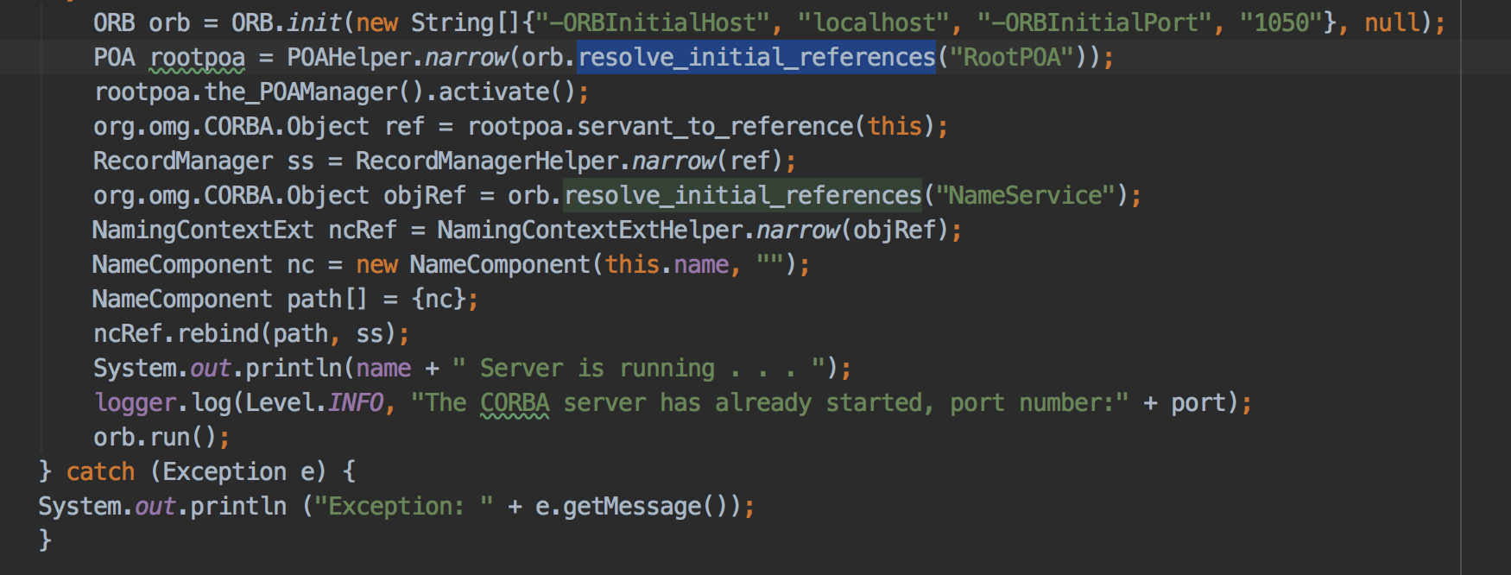

# Client Deployment in CORBA

In client side, we create CORBA pseudo-object by using ***init*** function and use CORBA naming service to find the server that it belongs to. Then we assign this server object to remote. Finally, we can use remote to execute the five functions that we have built in ***idl***. The code is shown below:

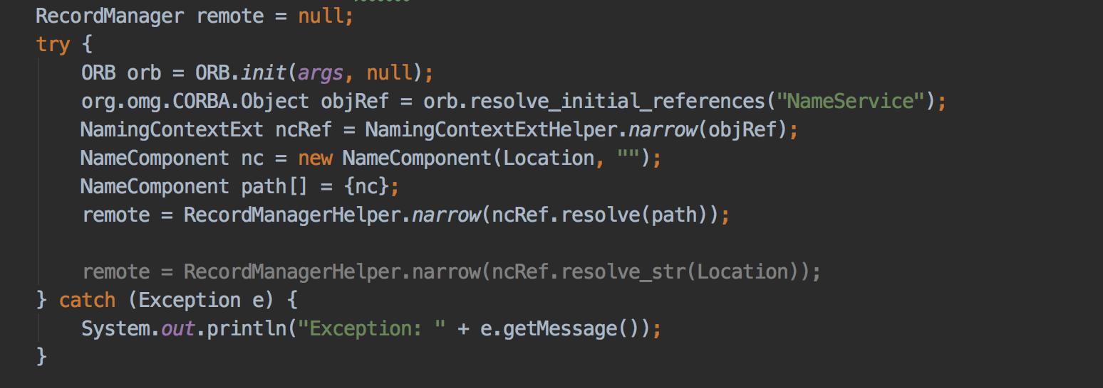

# Data structure, class and main method in the project

The class diagram of the ***RequestManager*** in CORBA is shown as below.

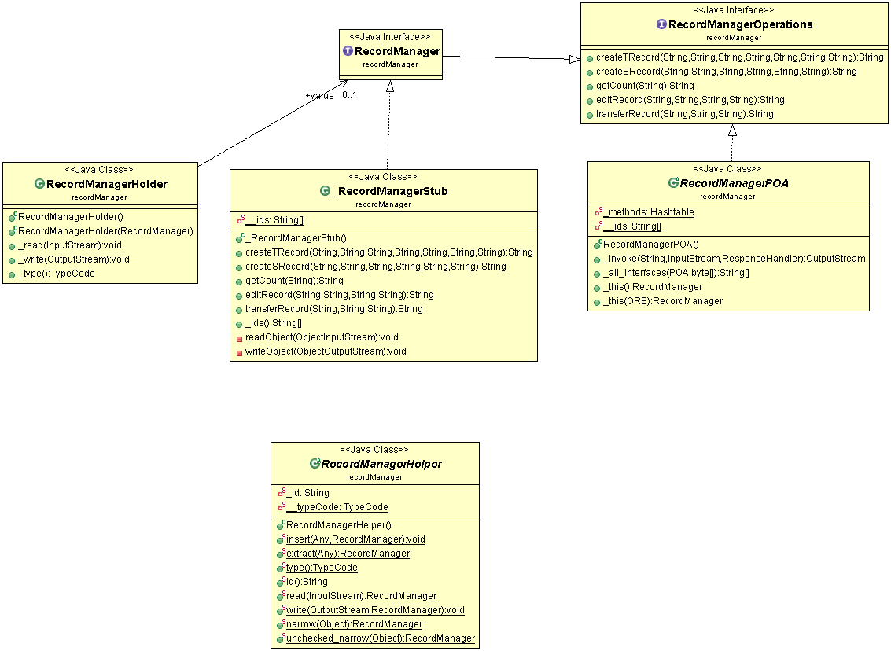



The main class structure is shown as below.

***Record*** is a base record for student record and teacher record, which has the common attributes.

***TeacherRecord*** and ***StudentRecord*** are extend from ***Record***, each of them has its own attributes for teacher or student.

***ManagerClient*** is the client end, which allow users to log in and execute create, edit or get count operations and then invoke the remote methods on the server then receive the response.

Server is the server end, which registry and bind the remote objects, and invoke a thread to listen to a port for UDP packets. ***MyLogFormatter*** is used to define the log format.

All the log files of servers will be named with the server name, and the log files for clients will be named with the client’s name.

**Class and main method in this project:**

1. Database: ***HashMap*** <***String***, ***List***<***components***>>

Key: String(A-Z) the first letter of last name

Value : Teacher: ***firstName***, ***lastName***, ***address***, ***phone***, ***specialization***, ***location***

Student: ***id***, ***firstName***, ***lastName***, ***courseRegistered***, ***status***, ***statusDate***

1. Method: ***createTRecord*** (***String***, ***String***, ***String***, ***String***, ***String***, ***String***, ***String***)

Attribute: ***managerID***, ***firstName***, ***lastName***, ***address***, ***phone***, ***specialization***, ***location***

1. Class: ***teacherRecord*** (***String***, ***String***, ***String***, ***String***, ***String***, ***String***)

Attribute:***id***, ***firstName***, ***lastName***, ***address***, ***phone***, ***specialization***, ***location***

Function: ***Getter*** and ***Setter*** methods, and ***editField***()

1. Method: ***createSRecord*** (***String***, ***String***, ***String***, ***String***, ***String***,***String***)

Attribute: ***managerID***, ***firstName***, ***lastName***, ***courseRegistered***, ***status***, ***statusDate***

1. Class: ***StudentRecord***(***String***, ***String***, ***String***, ***String***,***String***,***String***)

Attribute: ***id***, ***firstName***, ***lastName***, ***courseRegistered***, ***status***, ***statusDate***

Function: ***Getter*** and ***Setter*** methods, and ***editField***()

1. Class: ***Record***(***String***, ***String***, ***String***)

Attribute: ***id,*** ***firstName***, ***lastName***

Function: ***Getter*** and ***Setter*** methods, and ***editField***()

1. Method: ***GetCount***()
2. Method: ***ServergetCount***()
3. Method: ***transferRecord***(***String***, ***String***, ***String***)

***Atrribute***: ***managerID***, ***recordID***, ***remoteServerName***

# Synchronization for concurrency

To support multi-clients access to the server, it is important to ensure the consistency of the database (Hashmap). In this assignment, we use ***synchronized*** method to implement competition synchronization, to make sure that only one client could modify the database at the same time. However, to make the method more efficiency, we do not use ***synchronized*** keyword to declare the method, but to only synchronize only a part of block of the method, which only block a part of codes not the whole method.

# The logic for implementing the function transferRecord

After a server receives ***tranferRecord*** requirement, it will do several actions as below:

First, it will check if it contains the record which is asked to be transferred to another server. For example, if the server “MTL” gets a transfer a record whose id is “SR10003” to the other remote server “LVL”, the server will iterate all its record and checks weather it contains the record or not.

Second, to make sure that the remote server name is not the local server name, we check if the local server name equals remote server name we will continue the next action, else we will return wrong message.

Third, if all the information above is right, we will start to build a UDP request to ask remote server to transfer record data. In the remote server side, there is a while loop to get a request from other side. If the request is to transfer record, it will check if the record is already there. If not, the server will create the record and then tell the server which sent the request that the record is transferred successfully. Finally, the server who sent the request will delete the transferred record in its list and tell client the message that the record is transferred successfully. Else, the remote server will tell the server who sent the request that you cannot transfer this record and the request server will tell client that reason that transferring record is failure.

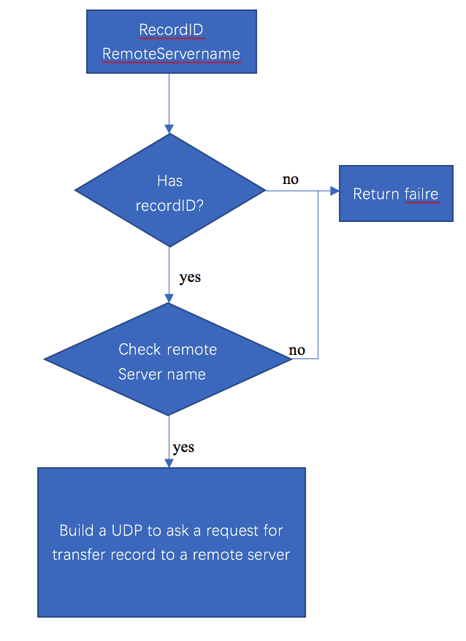

# Test case and Test scenarios

Scenario1. One client requests transferring record in the condition that the local server has the record and remote server does not has the record.

Expected: The action should be successful.

Test result:

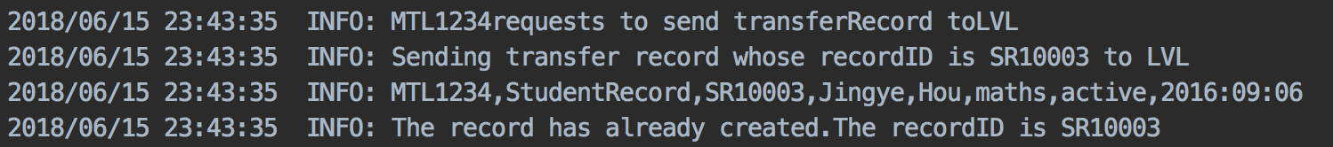

Scenario2. One client requests transferring record in the condition that the local server does not have the record.

Expected: The request for transferring record should be rejected.

Test result:



Scenario3. One client requests transferring record in the condition that the remote server has the same record.

Expected: The request for transferring record should be rejected.

Test result:

In the request sender server:

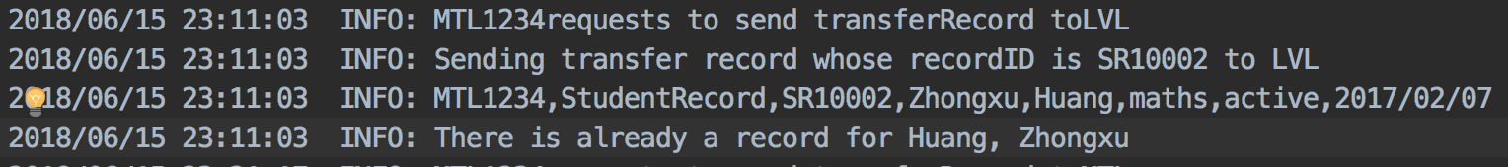

In the request receive server:



Scenario4. One client requests transferring Record in the condition that the remote server name is local server name.

Expected: The request for transferring record should be rejected.

Test result:



Scenario5. Multiple client request including ***editRecord***, ***transferRecord*** and ***createRecord***

REQUEST TRANSFER SR10003

REQUEST EDIT SR10003

MTL SERVER

REQUEST CREATE SR10003

Expected: The 1st request for transfer should be accepted if the remote server don’t have the same record. Thus, the 2nd request for editing should be rejected since the record has been transferred. And the 3rd request should be accepted.

Test result:

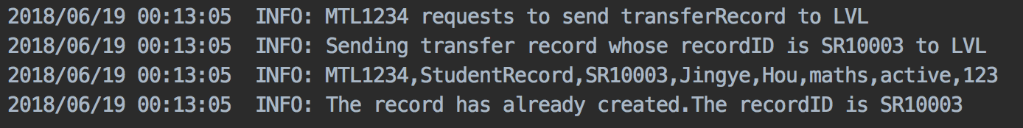





Scenario6. Multiple client request including ***editRecord***, ***transferRecord*** and ***createRecord***

REQUEST EDIT SR10003

REQUEST TRANSFER SR10003

MTL SERVER

REQUEST CREATE SR10003

Expected: All the request will be accepted if the remote server don’t have the same record.

Test result: 





# Most difficult part and important part in this assignment

Difficult part: When we implement the CORBA and set up servers, we did not know how many ports should we create. Finally, we found a solution for it. We use naming server to create three different path for the three servers.

The important part is that we need to know the architecture of the CORBA and how it works. Secondly, we need to think of synchronization when we check that if the record is listed in the local server record list and delete record from the record list.